**Task 1:**

Steps: 1) find single words which can lead to “A” and “I”,

Step2 ) use frequecy for top 3 charater which will get e and t. which will again make first word in cypher text as “The”.

Step 3) used frequency for 2 and 3 letter words to find others

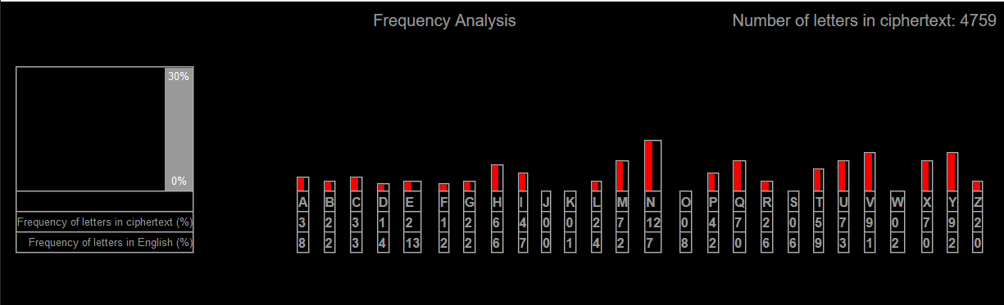

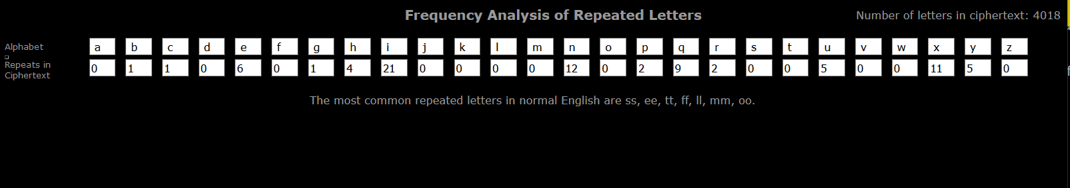

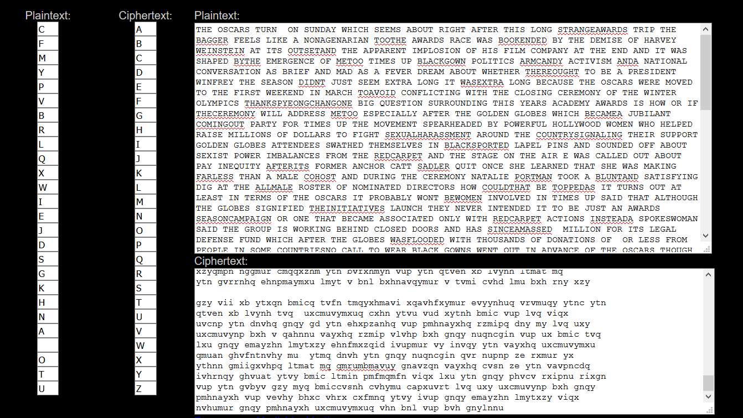

De-cypher and display first 4 line of the file

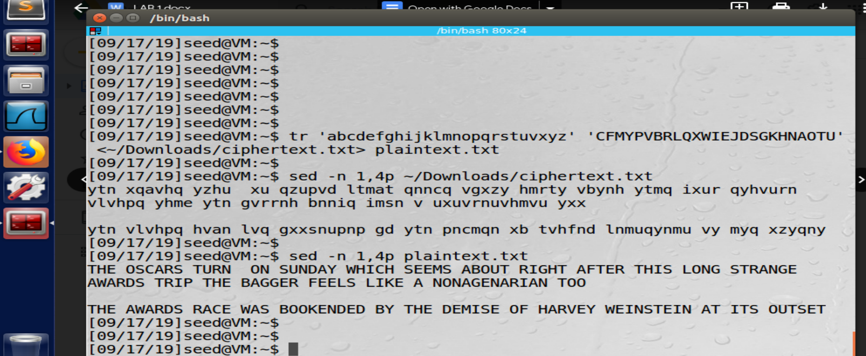

**Task 2:**

1. 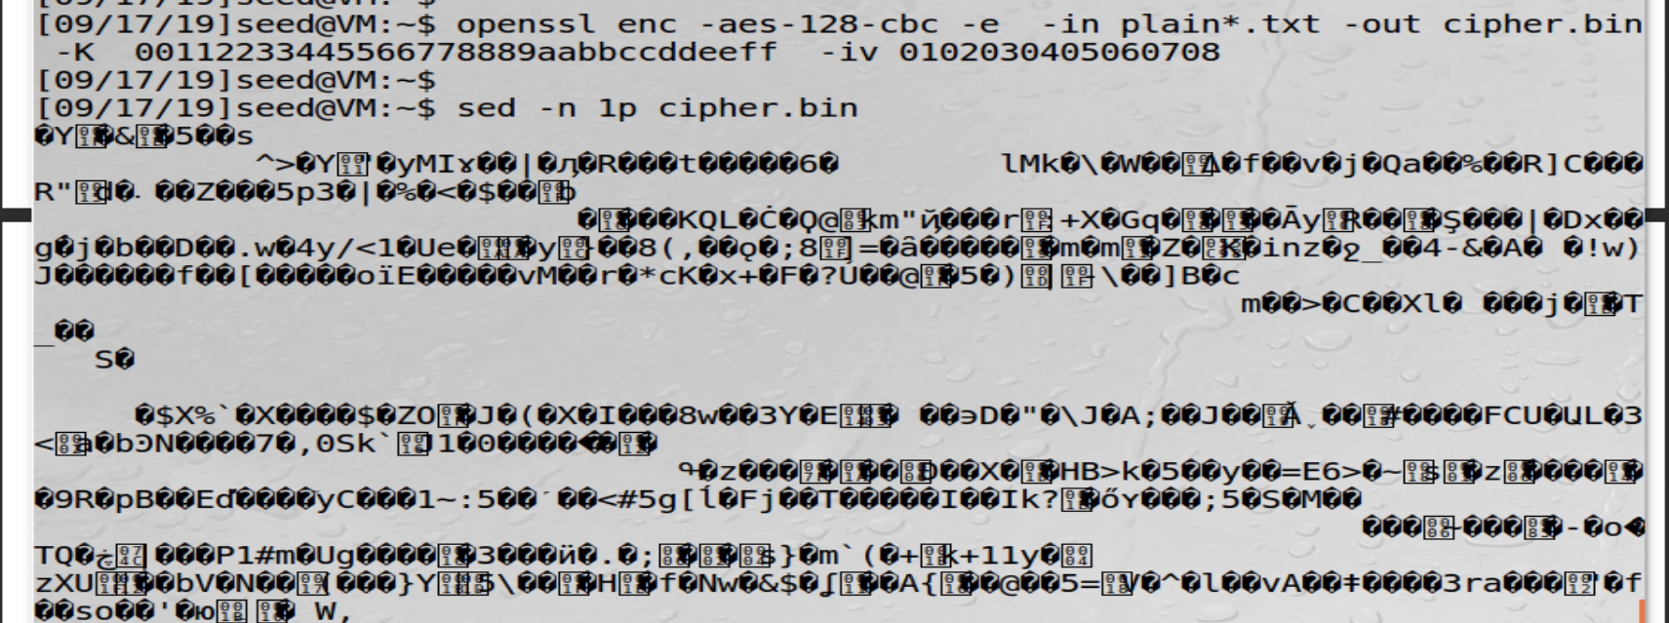
2. **-bf-cbc encryption**

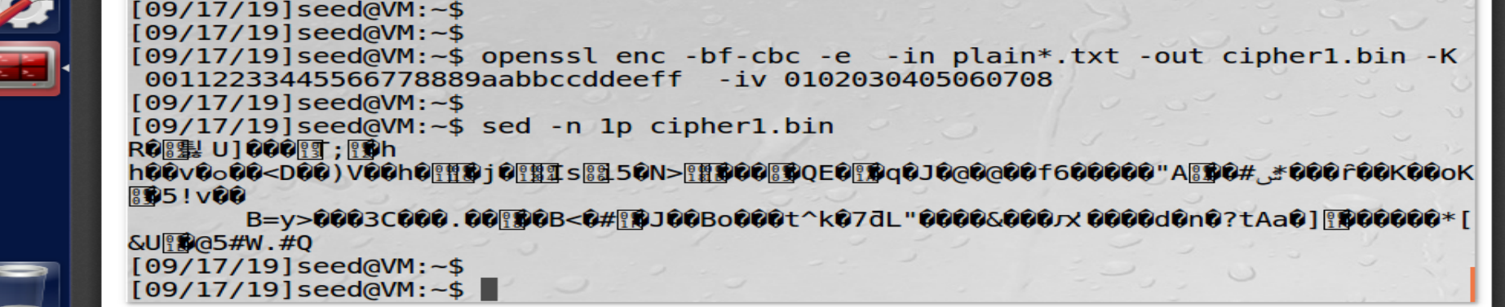

1. **-aes-128-cfb**

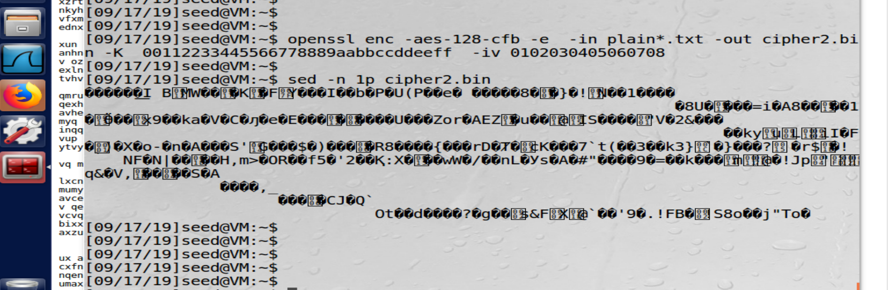

**Task3:**

1. Taken header part in “Header” and encrypted “full” with ecb and cbc
2. 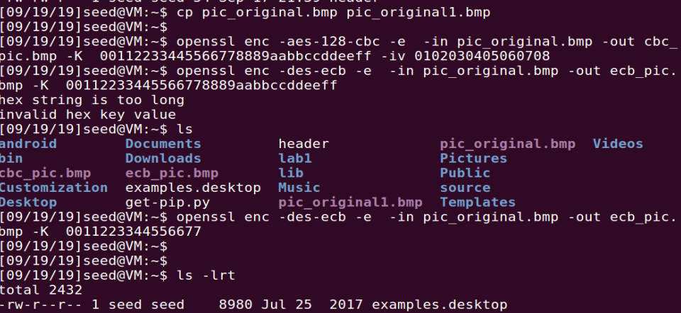

Taking body out from both encryption and adding and appending with non-encrypted header

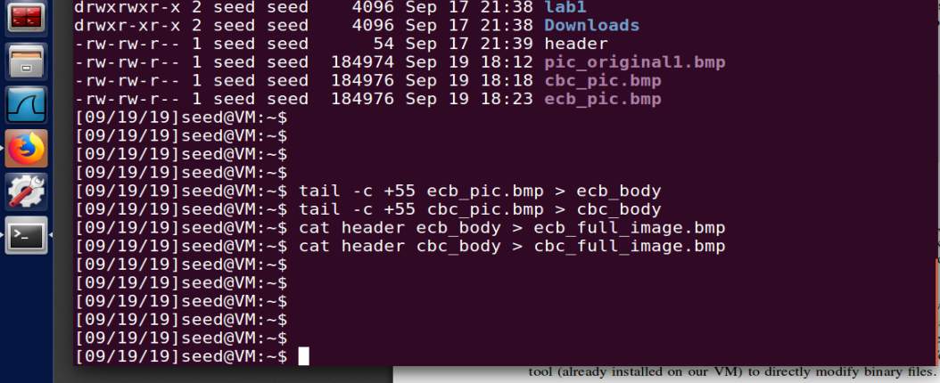

Cbc image and ecb image respectively

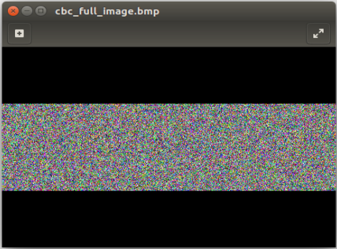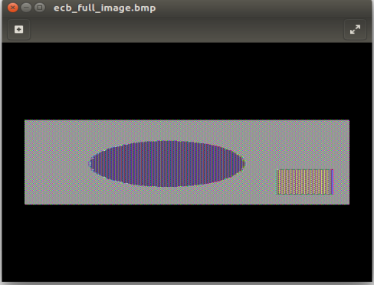

**Observation:** Original image will have mostly 3 type of blocks, white pixel , red pixel, green pixel.

As CBC uses IV from previous block to encrypt next block so whole information seems to be random,

But on the other hand, ECB encrypt each bock independently, so all block ( of same pixel) will be encrypted in same cypertext, for example most of red color block converted to pink color block.

**Task 4: Padding**

Created 3 files 5,10,15 byte

Encrypted them with cbc,ecb and decrypted to check padding. As we can see in below snapshot we have “0b” as padding till 16 byte block. While in 15byte file we have 1 byte padding

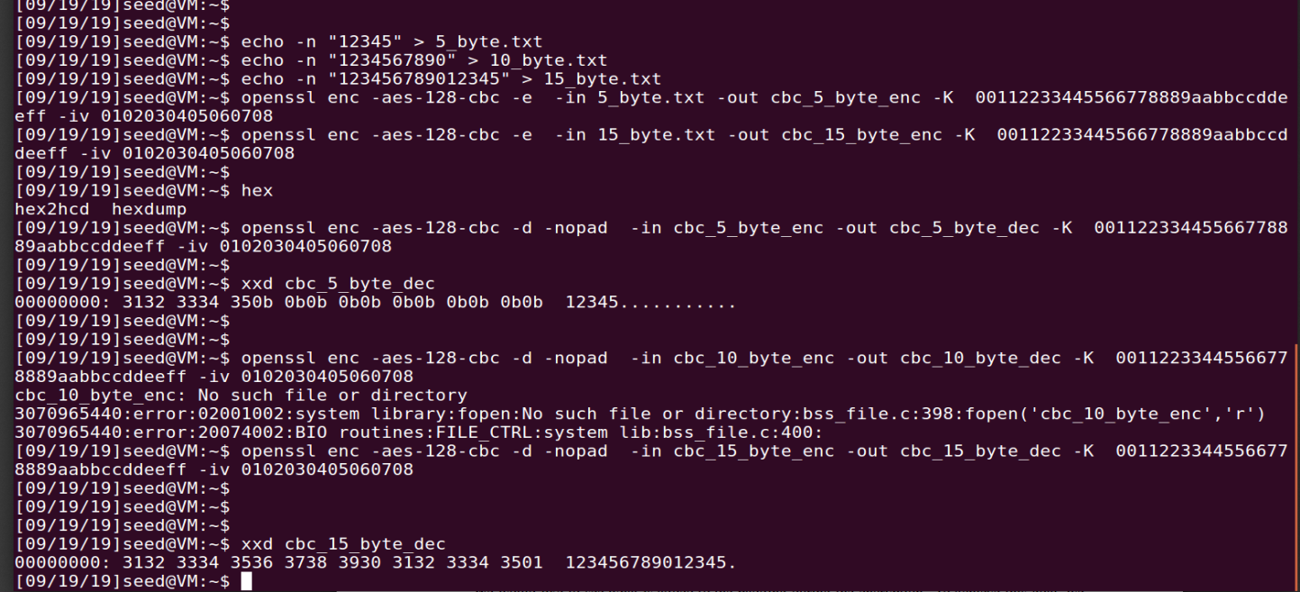

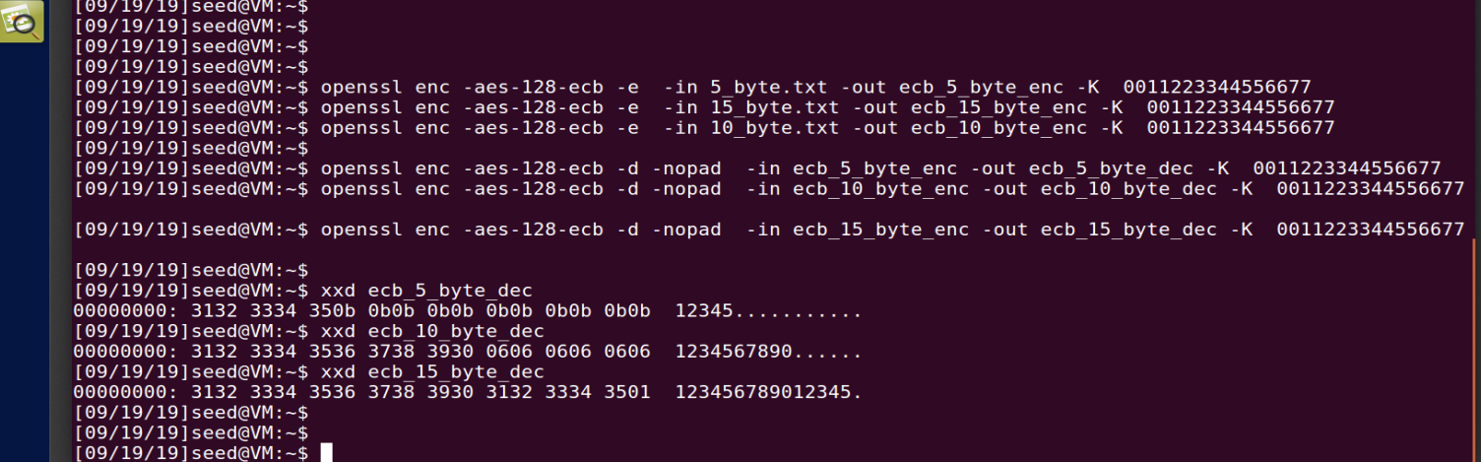

No visible padding in cfb and ofb

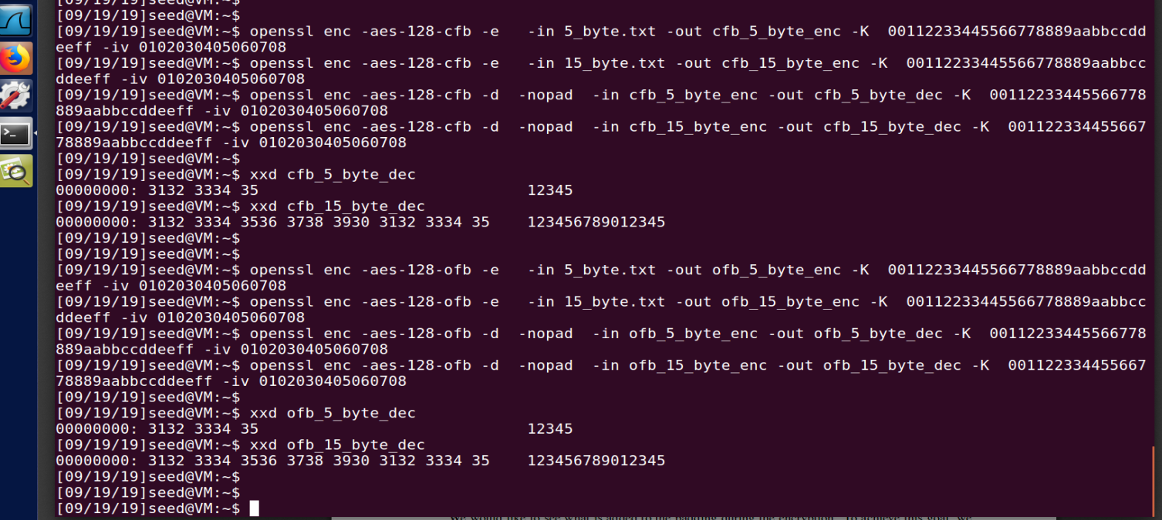

**ECB and CBC used padding(block cypher 16byte block size) while CFB and OFB didn’t(as they are stream cypher with 1 byte block size), it also supported by file size after decryption with padding**

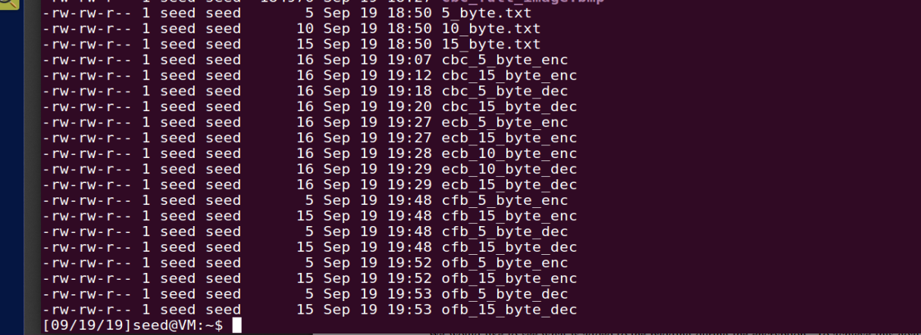

**Task 5:**

Create 1000byte file and encrypted them with ecb,cbc,ofc,ofc

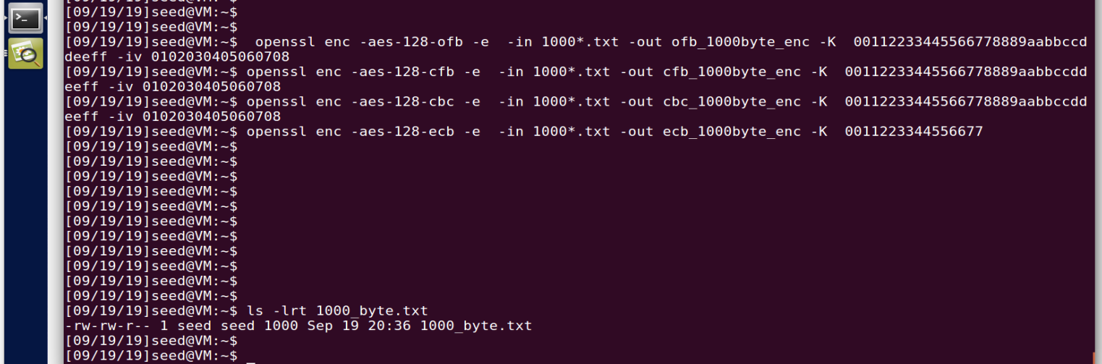

Ofc:

Uncorrupted encryption:



Corrupted one byte at 55th location:



Decrypted and compared: “d” in original became “g”; Only one bit is corrupted in plaint text.

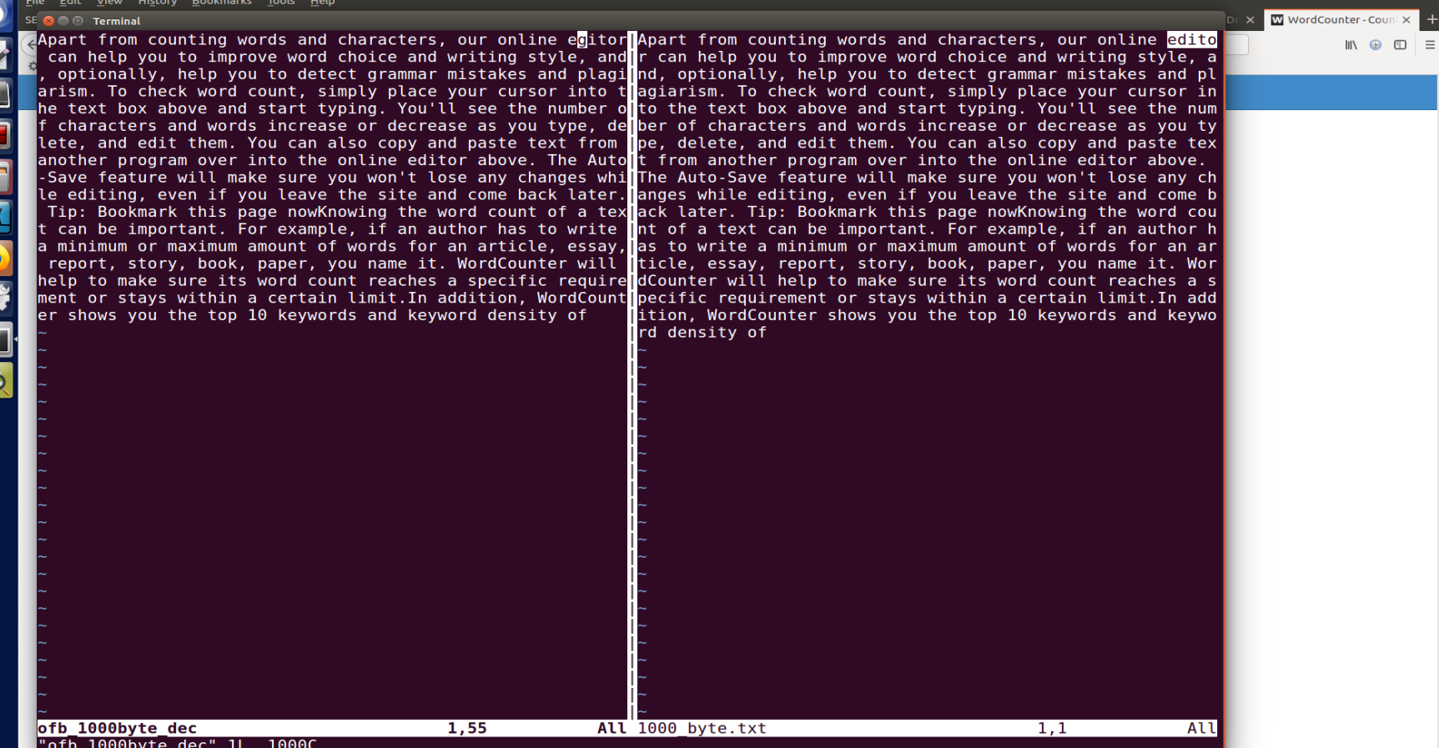

CFB : on changing 1 byte. Whole block got corrupted

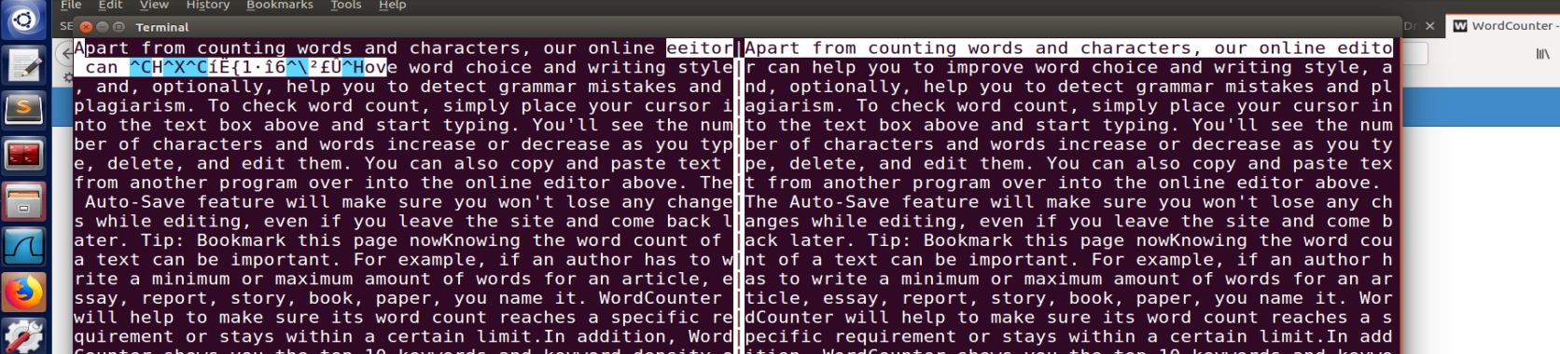

CBC: whole block is corrupted

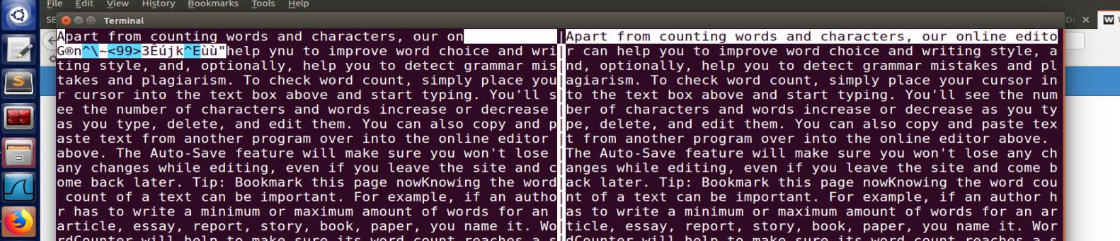

ECB: one block(16byte) corrupted

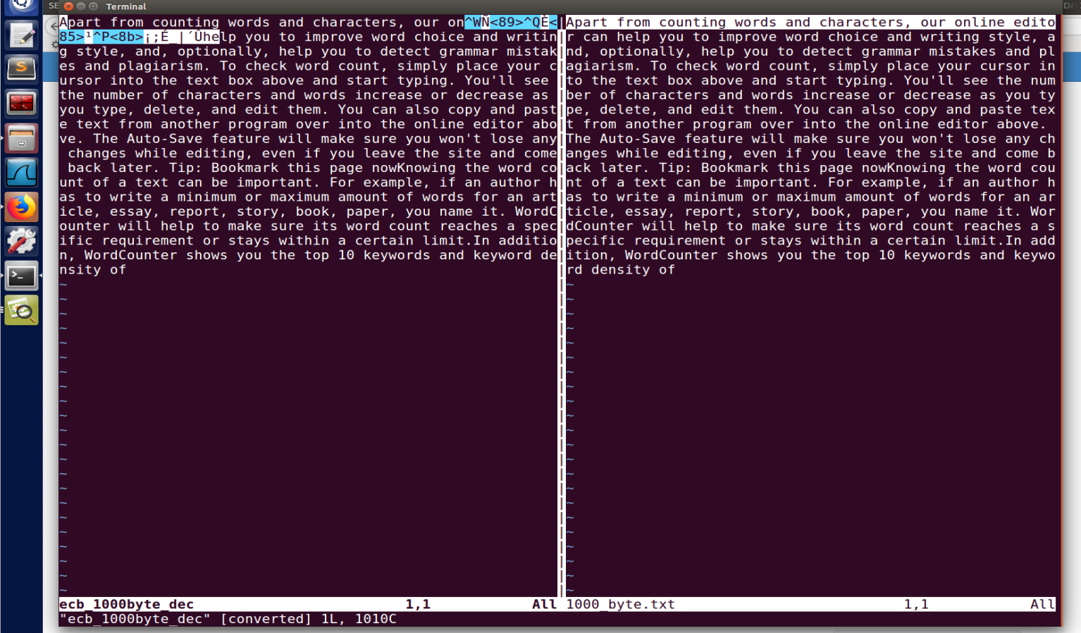

**Task 7: Program**

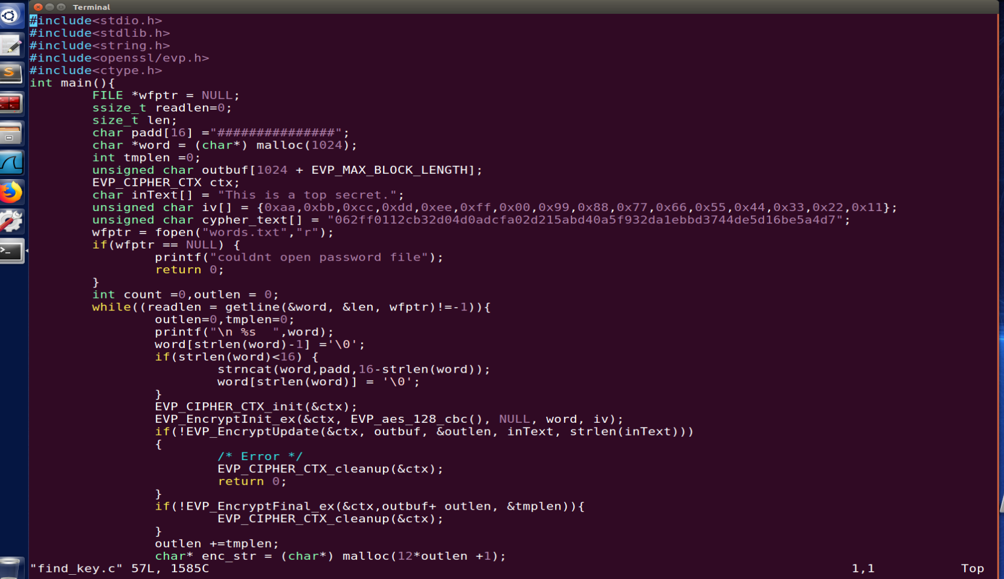

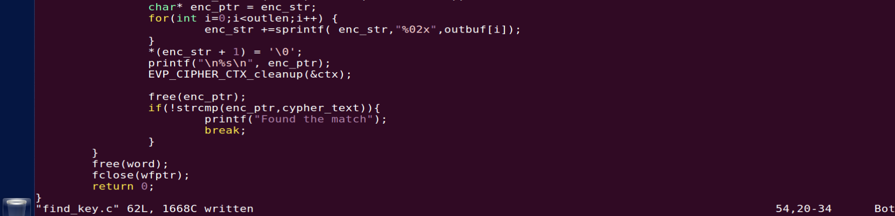

Running



**Key used for encryption: “secret”**

